ASSIGNMENT-1.5

HT.NO : 2303a52438
Name : T.Rishitha
Batch-45

TASK-1
PROMPT:
Write a simple and easy-to-understand Python program that takes a string as user input, reverses it step by step using basic logic, prints the reversed string, and does not use any user-defined functions.
CODE:
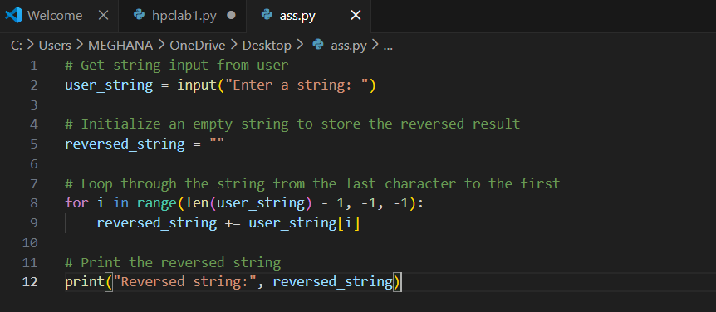
OUTPUT:
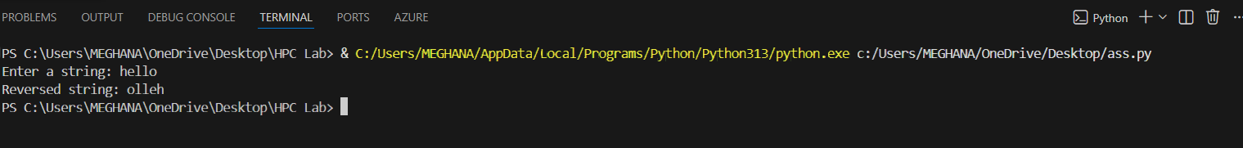
JUSTIFICATION:
This prompt is good because it helps beginners practice the basics of Python. It focuses on simple input, loops, and string handling without shortcuts. The task is clear, easy to measure, and builds real understanding step by step.

TASK-2
PROMPT:
Give Python code that reverses a string simpler, easier to read, and faster, without using functions.
CODE:
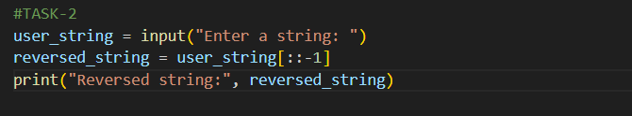
OUTPUT:
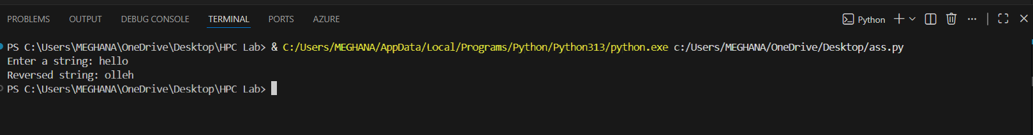
JUSTIFICATION:
This prompt is justified because it helps learners practice a fundamental Python skill in a way that is clear, efficient, and beginner‑friendly, while focusing on readability and performance.

TASK-3
PROMPT:
Write a Python program that defines a function to reverse a string, returns the reversed string, uses the function in the main program, and includes meaningful comments explaining each step.
CODE:
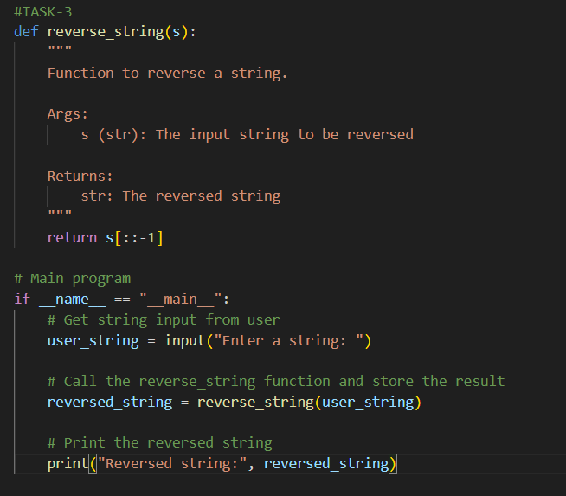

OUTPUT:
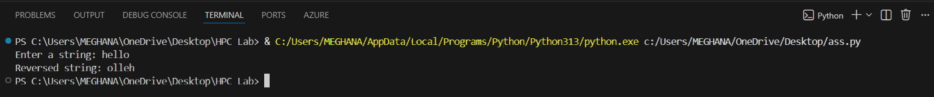
JUSTIFICATION:
his prompt is well-designed for teaching clean, modular Python programming while reinforcing core concepts through a simple, focused task.

TASK-4
PROMPT:
Write a Python program that compares two string reversal approaches: one without functions and one using a user-defined function. Analyze them based on code clarity, reusability, debugging ease, and suitability for large-scale applications, and display the comparison in a clear table or summary.
CODE:
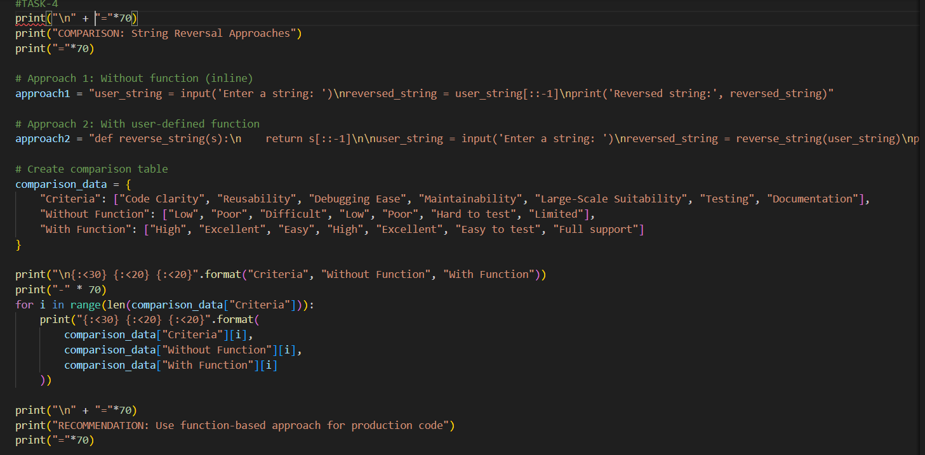

OUTPUT:
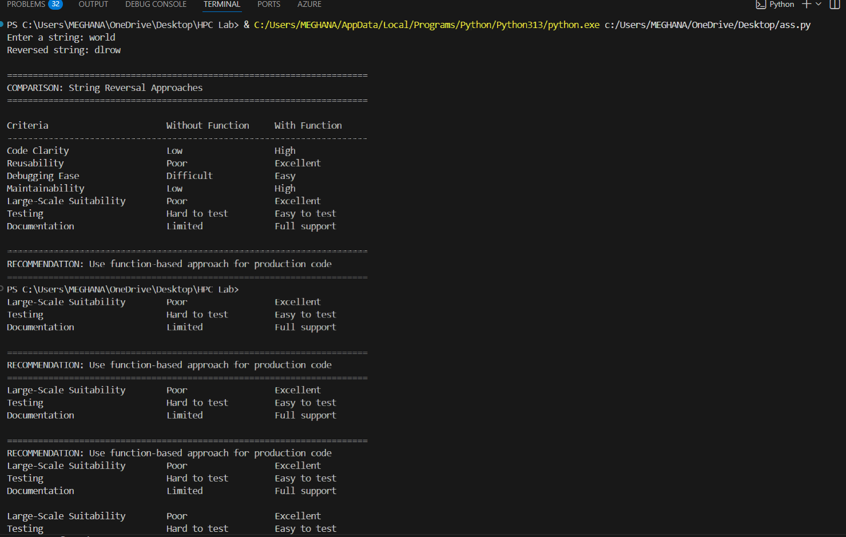
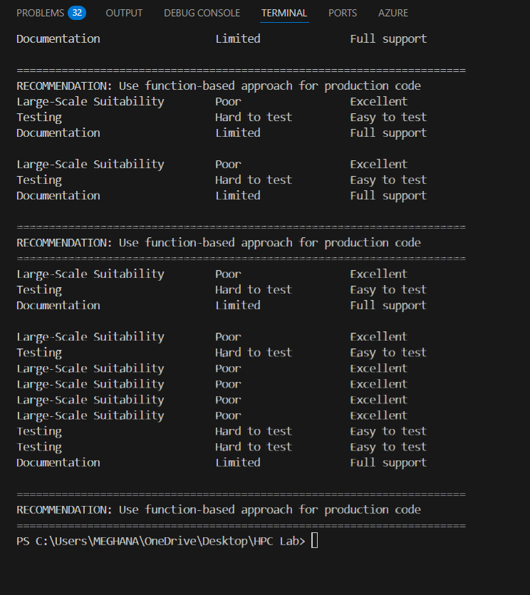

JUSTIFICATION:
This prompt is justified because it teaches both coding and evaluation skills, helping learners understand not only how to solve a problem but also why one approach may be better than another in larger applications.

TASK-5
PROMPT:
Write Python code to reverse a string using both a loop-based approach and a slicing approach, with comments, sample output, and a comparison of execution flow, time complexity, performance for large inputs, and appropriate use cases

CODE:
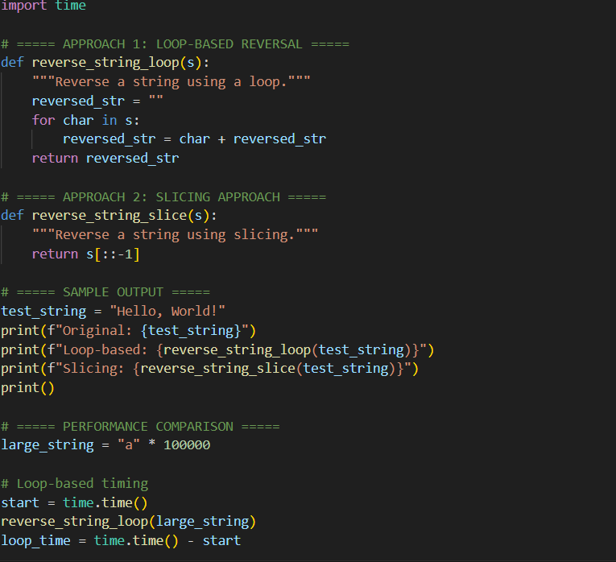

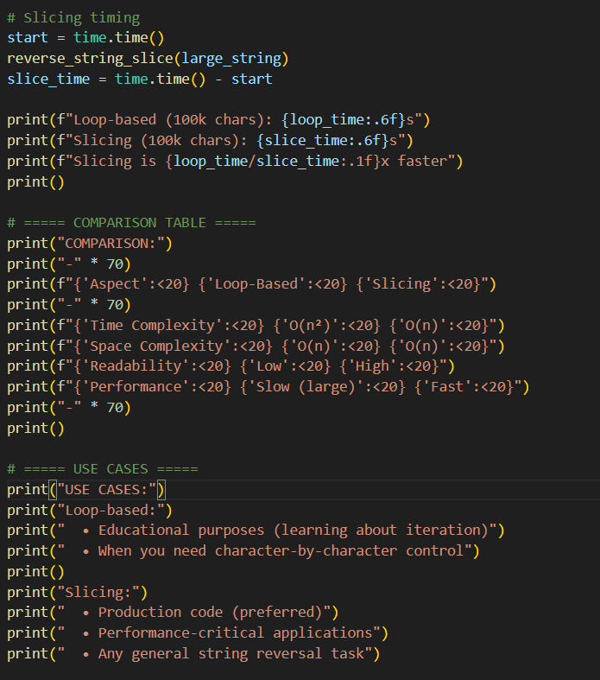

OUTPUT:
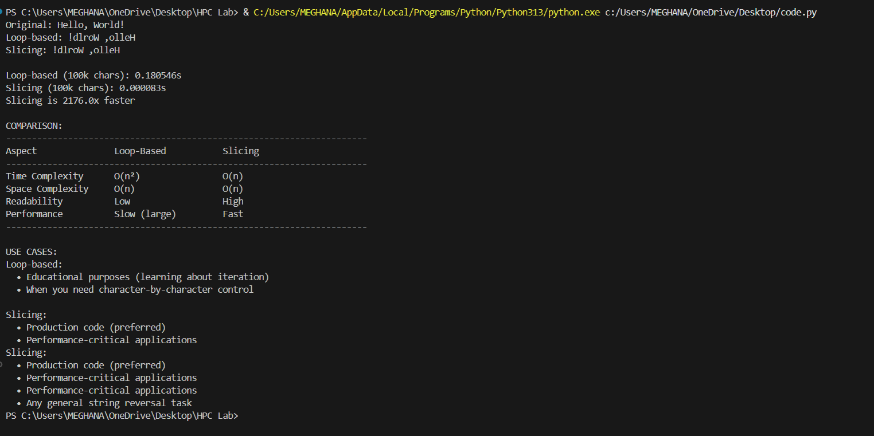
JUSTIFICATION:
This prompt is justified because it teaches coding and evaluation skills, helping learners write solutions while understanding efficiency, readability, and practical use. It builds a solid foundation for clean, efficient, and well-documented Python code.

